Do all your work and submit answers with your work, on the separate paper provided. Organize your work for efficient grading and feedback. Leave a margin, especially in the top left, where the staple goes! Found two significant typos in #s 1 and 4. I have highlighted the *corrected* integrals.

1. (10 pts) Evaluate the iterated integral  by changing the order of integration. This will put you through your paces on integration. You can probably find a table that gives the antiderivative of , but I didn’t have much trouble just using *u*-substitution twice, by letting  about halfway through. This is a take-home, so I’ll want you to crank it all the way out, and I’ll charge something significant if you don’t, unlike the sit-down test.
2. Two questions for polar coordinates:  
   1. (10 pts) Derive the increment of area in polar coordinates using the Jacobian on the transformation   
      . In the language of transformations, . We have  in the *xy*-plane and we want to obtain the well-known:
   2. (10 pts) Use polar coordinates to find the volume of either of the two solids described:
      1. the solid bounded by the paraboloids  and ` or...
      2. the region inside the sphere  and outside the cylinder .
3. (10 pts) Derive the Jacobian for the change-of-variables from rectangular to spherical coordinates. I made an abortive attempt in class, Thursday. Clean up my work.
4. (10 pts) Write 5 other iterated integrals that are equivalent to the iterated integral 
5. 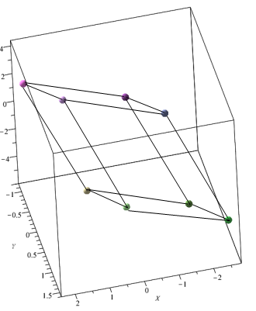(10 pts Bonus) Find the volume of the parallelepiped bounded by the planes   
   One way to do this is to recognize it as a triple integral over the enclosed region, and perform a change of variables to *u*, *v* and *w*. but you could also find 1 vertex and 3 adjacent vertices and perform a scalar triple product on 3 vectors defining the parallelepiped. But that would be pretty difficult and extremely time-consuming, requiring you to find at least 4 appropriate vertices of the monstrosity in the *xyz*-coordinate system given on the right. And yes, it *is* the actual region, and no, don’t ask me how long it took me to render it.

A clever student would recognize *T* as a linear transformation represented by the action of the matrix  on the vector  under multiplication to give us *u*, *v* and *w* in terms of *x*, *y* and *z*, that is, and know how to find *x*, *y*, and *z* by finding the inverse matrix to give us *x*, *y*, and *z* in terms of *u*, *v* and *w*. An extremely clever student would realize that the Jacobian would then be the determinant of that inverse matrix. A *wickedly* clever student would know that the determinant of the *inverse* matrix is the *reciprocal* of the determinant of the matrix of the linear transformation *T* , compute the determinant of *T* and take its reciprocal! This is the nice thing about straight-edged regions, which give rise to linear transformations from the *xyz*-coordinate system to the *uvw*-coordinate system! Wicked!  
If you followed all this, you can find the Jacobian  in about a minute. Do that, but *also* solve the system of equations  for *x*, *y* and *z*, and compute the Jacobian as the absolute value of the scalar triple product, given by , since the determinant of the transpose is the same as the determinant of the original matrix. Your book gives it the last way. I think laying it out the way I do it is more in keeping with the theory and how you want to think of it. In Linear Algebra, they do lay things out in columns, usually, but we do everything in rows in Calculus III when we’re introducing the vector theory.