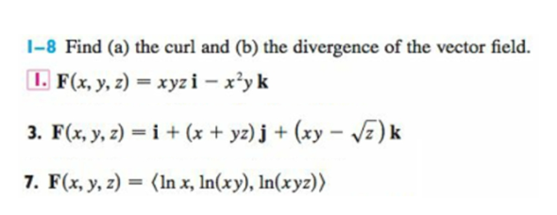

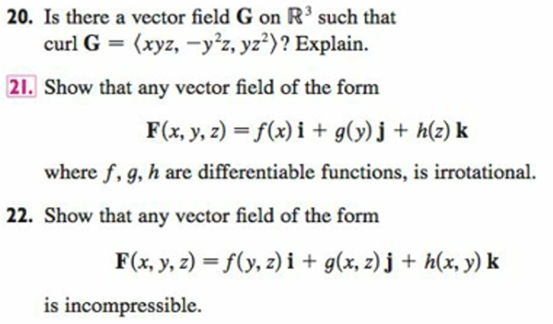
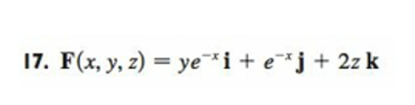
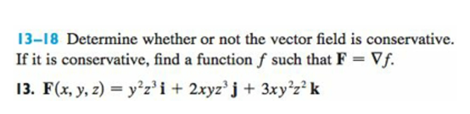

#20 Compute the divergence. #21 Compute the divergence. #22 Compute the divergence.
See the following page for exercises for which we don’t have time, but would be good muscle-builders for physics and engineering:

#29 is the one that’s needed for the later exercises.
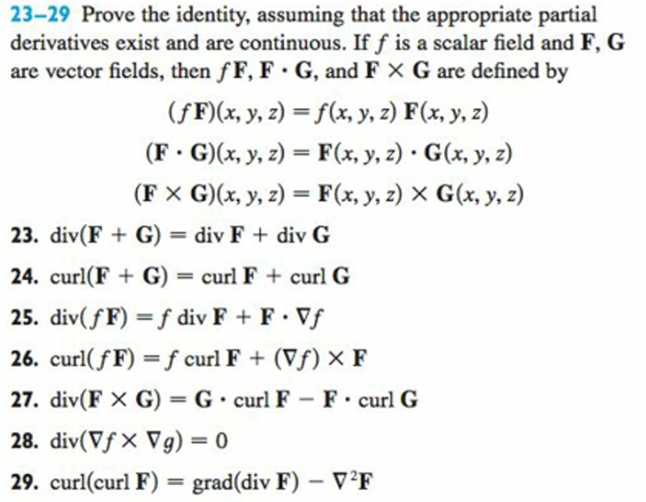
Maxwell’s Equations. HUGE for applied math and engineering. Some preface these equations with “God said...” because they describe how the universe works.
