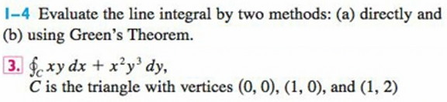
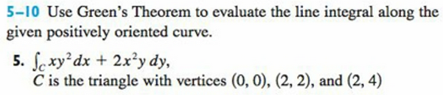
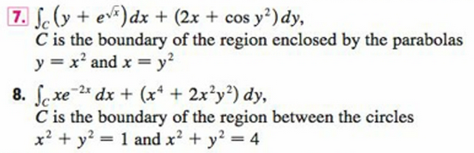
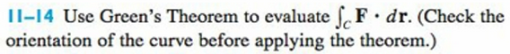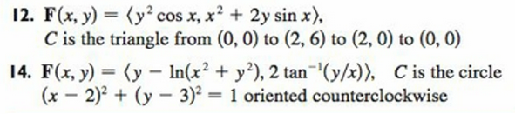
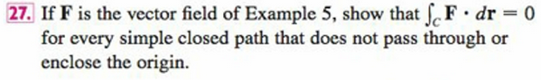
Remember this if you’re ever in Complex Analysis.

