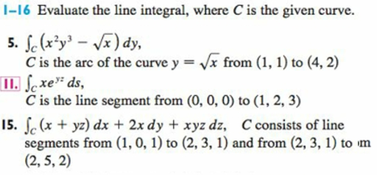
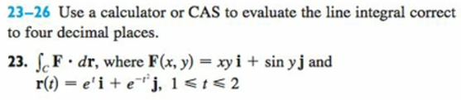
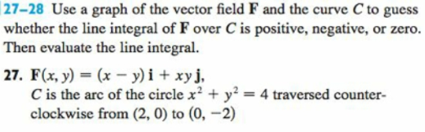
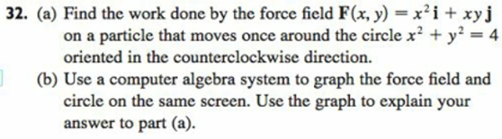
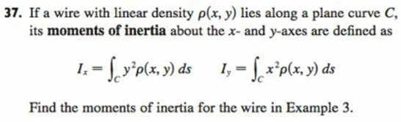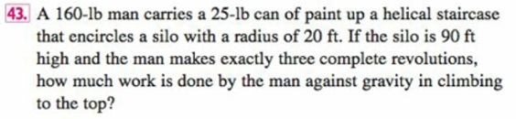
(Fact: You should discover that the work done against gravity is independent of path.

