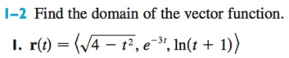
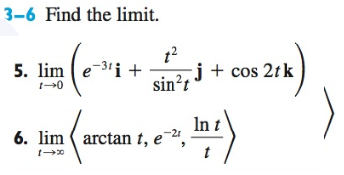
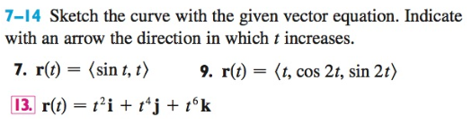
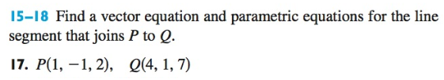
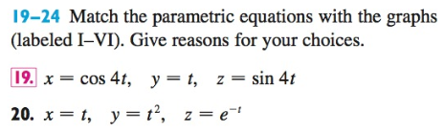
Figures on Page 2
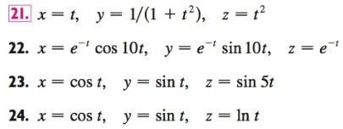
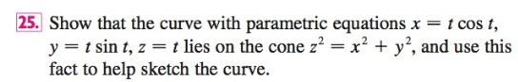
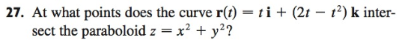

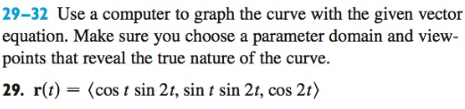
Don’t panic if you don’t have access to Computer Algebra System for #29. FYI and FWIW, I entered this into Wolframalpha.com: 3D parametric plot r(t)=<sin(t),cos(t),t> for t = 0 to 8*Pi
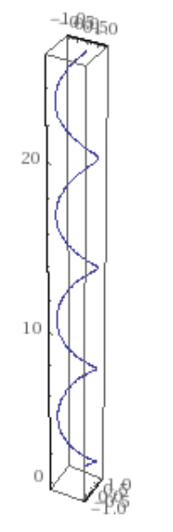
And it gave the plot seen on the right:
