Do a nice write-up of these two problems. Do scratch work and scribbles on separate paper, but fit a nice, cogent solution onto this sheet. Thx.

1. 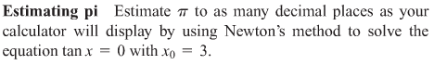



2. 