I think you know the drill on margins and legibility. I can’t give points for what I can’t read. Take a minute, at the end, to make sure your work is organized and submitted in proper order.

1. 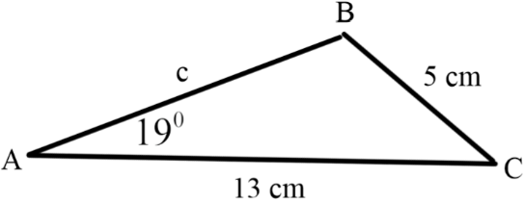Consider the triangle in the figure. Do not use rounded results in your calculations for new results. Only round in the final answer to each of the following:  
   1. (10 pts) This triangle is oriented a bit differently than others you’ve seen for this SSA situation. But you can still show there are 2 solutions to this triangle. Do so.
   2. (10 pts) Draw the picture for the case where angle B is acute and angle C is obtuse. You probably have already drawn it, in your answer to the previous question. In the figure, I’ve given the picture for an obtuse angle B and acute angle C. Don’t worry about the length c, yet. That’s part e.
   3. (10 pts) Choose the picture where the angle B is obtuse (the one I’ve drawn), and use the Law of Sines (and pictures and logic) to find (obtuse) angle B, to 4 decimal places.
   4. (10 pts) Use angle A and your (un-rounded) result for angle B to find angle C in the obvious way (subtraction!), to 4 decimal places.
   5. (5 pts) Use your (un-rounded) result for angle C and the Law of Cosines to find the length of  
      side c. You can check your answer using the Law of Sines, but I insist on seeing the Law of Cosines, here. Give the length c rounded to 4 decimal places.
2. 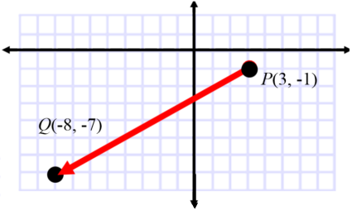Consider the directed line segment  in the figure on the right. I want you to provide some basic facts about the vector :  
   1. (10 pts) Express the vector  in component form.
   2. (10 pts) Compute the magnitude of . Leave your answer in simplified radical form.
   3. (5 pts) Find the direction angle of (the positive angle measured from the positive *x*-axis). Use degrees, rounded to 4 places.
3. Let .
   1. (10 pts) Express  as a linear combination of the canonical (standard) unit vectors  and .
   2. (10 pts) What’s another word for the sum of 2 vectors?
4. 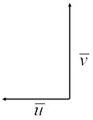The current in a river is flowing at 5 miles per hour, due West. . A man in a boat points his boat due North to attempt a crossing. His boat’s speed is 10 miles per hour .  
   1. (5 pts) Express  and  in component form.
   2. (5 pts) How far downstream will the current take the boat, if the river is 1 mile wide?

BONUS Answer up to 4 of the following for up to 20 bonus points.

1. Let .  
   1. (5 pts) Use synthetic division to show that  is a solution of the equation .
   2. (5 pts) Find the linear factorization of  that is promised to us in the Fundamental Theorem of Algebra.
2. Let
   1. (5 pts) Find , where  is the complex conjugate of *z* .
   2. (5 pts) Express  *z* in trigonometric form.
3. Let .
   1. (5 pts) Express *z* in standard form.
   2. (5 pts) Find the trigonometric form of the principal 4th root of *z*, i.e., find .
   3. (5 pts) Now, find *all* the 4th roots of *z*, in trigonometric form.
   4. (5 pts) Find the trigonometric form of .
   5. (5 pts) Finally, let , and find the trigonometric form of the product .
4. (5 pts) Find the *exact* value of , if .
5. (5 pts) In what quadrant does 2*u* lie, if 