All I want on this cover sheet is your NAME.

Do all work and put all answers on the white paper provided. ***Exception*:** For #2 and Bonus 2, write directly on the test sheet. Do not write on the backs of the white pages. Leave a margin at the top left corner on every page. "201-G11" works really well for the top left corner of every page.

Leave room between problems. Do not squeeze work in to fit a page. Start a fresh page. When in doubt on how long a problem will turn out to be, start a fresh page.

1. Let 
   1. (5 pts) Find an equation of the tangent line to  *f* at .
   2. 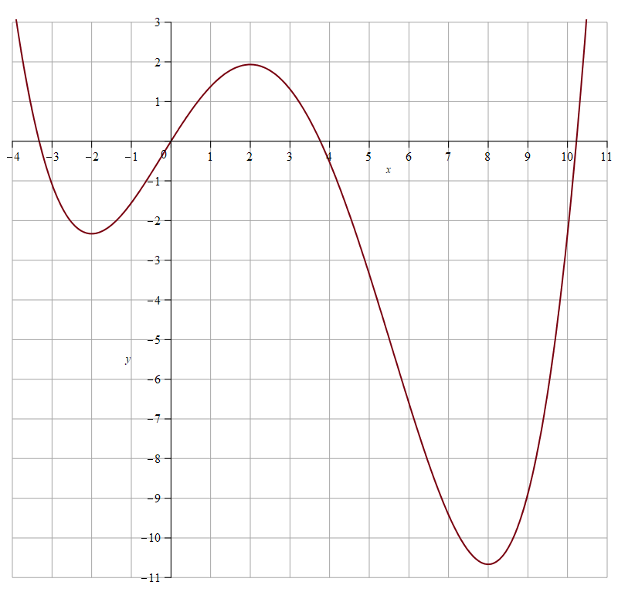 (5 pts) Sketch a graph of  and the tangent line to *f*  at .
2. (10 pts) The graph of a function *f* is given on the right. On the same set of axes, sketch a graph of . (There's a blank one of these on Page 2 of the test. Do your work on it.)
3. Differentiate the following with respect to the indicated independent variable. **Do not simplify!**
   1. ; *x*.
   2. ; *x*.
   3. 
   4. ; *w*.
   5. ; *x*.
4. Consider the relation .
   1. (10 pts) Use implicit differentiation to find 
   2. (10 pts) Find an equation of the tangent line to the curve at the point .
5. (10 pts) A man who is 6 feet tall is walking away from a street light at 4 feet per second. If the light is 20 feet off the ground, how fast is the tip of the man’s shadow moving away from the light when the man is 30 feet away? Round your final answer to 3 digits to the right of the decimal.
6. (10 pts) Use a differential to approximate . Is your estimate very good? Compare your result with your calculator’s idea of .

Be sure to see the back for Bonus!

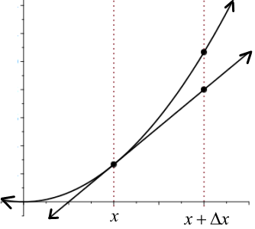BONUS SECTION: Work up to 15 points' worth.

1. (10 pts) Prove that 
2. Use the figure at the right:
   1. (5 pts) Show .
   2. (5 pts) Is the tangent line an over- or under-estimate? Why?
3. (5 pts) Sketch the graph of . Show all intercepts and asymptotes.

Graph for #2:

