Do your own work. SHOW your work. When in doubt about how stupid I am, assume the worst.

1. Solve the following inequalities. Give the solution in set-builder notation and interval notation.
   1. (10 pts) 
   2. (10 pts) 
   3. (5 pts) 
   4. (5 pts) 
2. Solve the following equations, by any method, other than copying a classmate.  
   1. (20 pts) 
   2. (10 pts) 
3. (10 pts) 
4. (10 pts) Simplify . Assume all variables represent nonnegative real numbers. Your final answer should contain only positive exponents.
5. (20 pts) Simplify 
6. (20 pts) Answer one of the following.
   1. A man bought a book on sale at a 20% discount. If he paid $37.00 at the register (after the discount!), what was the original price of the book (before the discount!).
   2. John can paint a room in 7 hours. Jane can paint a room in 5 hours. How long does it take them, working together?
7. (10 pts) Solve  by completing the square.
8. (10 pts) Re-write the function  in the form  and sketch the graph. Your graph should include Vertex, both *x*-intercepts and the *y*-intercept.
9. (10 pts) Use synthetic division to determine  for . In other words, divide  by , using synthetic division, and interpret!
10. (10 pts) Use long division to determine the quotient and remainder for . Write your final answer in the form of 
11. (10 pts) Sketch the graph of the system of inequalities: . Clearly label the “Good Stuff!”
12. (20 pts) Write an equation for the line shown in the picture:

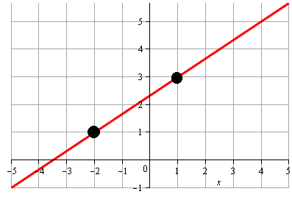

Answer up to 2 bonus questions for up to 20 points. I will grade the first 3 you do work on, unless you tell me to omit them.

1. (10 pts) Consider the equation . Write the discriminant.
2. (10 pts) What’s the solution of the equation ?
3. (10 pts) Solve  by completing the square.
4. (10 pts) Write  in the standard form .
5. (5 pts) Use Pascal’s triangle to expand 