This take-home test is due in one week (April 23rd). Do your own work. Ask me if you have a question.

1. (2 pts) Is (x, y) = (3,-7) a solution of the system ?

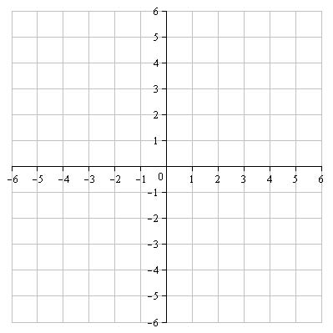
2. (20 pts) Solve the system of linear equations by graphing. (Hint: Using the slope and the y-intercept to graph worked really well when I did this one.)
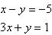

Use this cover sheet for your graphical solution. It’s nicely formatted.

Otherwise, I just want to see your name at the top.

The rest of your work I want to see on separate paper.

3. (20 pts) Solve the following system of linear equations by the substitution method:

4. (20 pts) A Chemist has an unlimited supply of both 25% and 44% nitric acid solutions. He wants 100 liters of 30% nitric acid. How much of the 25% and 44% solutions should he mix together to accomplish this?

5. (20 pts) For the following problem, I’m only looking for the setup. That means:
a. Define the variables in words and give the units.
b. Write the system of linear equations corresponding to the problem situation.

A dietician is trying to put together her own brand of trail mix, by mixing three brands (Brand X, Brand Y, and Brand Z) of trail mix, so that hers will have 21 grams of fat, 50 grams of carbohydrate and 68 grams of protein per serving. The three brands of trail mix supply these according to the following table, that gives the number of grams of fat, carbs and protein per unit of each brand.

How many units of each brand of trail mix should she use to make her brand of trail mix? Remember: Setup only. Don’t try to solve the system, after you’ve built it.

Brand | Fat (Grams) | Carbs (Grams) | Protein (Grams)
X | 1 | 2 | 3
Y | 3 | 7 | 9
Z | 2 | 5 | 7

