Do your own work. SHOW your work. When in doubt about how stupid I am, assume the worst.

1. (10 pts) Find the slope of the line between the points .
2. (5 pts) Find an equation of the line with slope , and *y*-intercept .
3. (5 pts) Find an equation of the line with slope  that contains the point .
4. (5 pts) Find the slope-intercept form of the line you obtained in #3.
5. (5 pts) Find the standard form of the line you obtained in #3. Your work from #4 should have you partway home on this one.
6. (10 pts) Find an equation of the line whose graph is shown. (Hint: Pick your points in such a way as to make the arithmetic easier.)

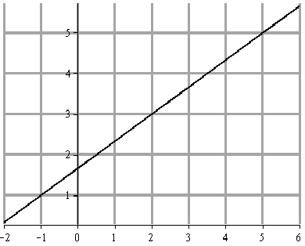

x

y

1. (10 pts) What is the slope of a line that is…
   1. … parallel to the line ?
   2. … perpendicular to the line ? (Basing your answer on part a is just fine.)
2. (10 pts) Sketch the graph of the linear inequality .
3. (5 pts) Sketch the graph of the line .
4. (20 pts) Let  and . Find and simplify the following:
   1. 
   2. 
   3. 
   4. 
5. (5 pts) Let . Simplify the difference quotient .
6. (10 pts) Suppose *y* varies jointly with *x* and *w* and inversely with the square of *z*. If *y* = 10, when   
   *x* = 4, *w* = 5 and *z* = 2, please come up with an equation relating *y* to *x*, *w*, and *z*. Then use that equation to tell me what *y* is when *x* = 7, *w* = 3 and *z* = 4.

Answer up to 2 bonus questions for up to 15 points. I will grade the first 2 you do work on, unless you tell me to omit them.

1. (5 pts) Consider the equation . Write the discriminant.
2. (5 pts) What’s the solution of the equation ?
3. (5 pts) Solve the inequality 
4. (5 pts) Factor  into the product of two binomials.
5. (5 pts) Factor 
6. (5 pts) Use Pascal’s triangle to expand 
7. (5 pts) Factor  (It doesn’t factor over the rationals! Your ‘ac’ method won’t work!).